Great Commission Equipping Conference

Training Leaders to Impact the World and Finish The Great Commission

Phase Two: Argentina

A Great Commission Conference

Sponsored By:

IPHC World Missions Ministries, in partnership with Mission Catalyst International

WHAT OTHERS ARE SAYING ABOUT THIS TRAINING:

- “I am more than seventy years of age and have attended conferences my entire life, but I have never attended a conference which impacted me like this.” (India Pastor)

- “This conference changed my life forever. God spoke to me and I will never be the same. It has given me new insight and direction for my life.” (Pakistani Pastor)

- “The Great Commission Conferences of Mission Catalyst are making a significant impact on our entire national church planting movement in Cambodia and helping touch our country for Christ.” (Cambodian Ministry Leader).

- “This conference changed my life. It gave me the clear direction for ministry that I was desperately in need of.” (Ugandan Pastor)

- “Our ministry has been abundantly blessed by this training. The response has been amazing. Never before had we been challenged about finishing The Great Commission and transforming our churches to become Great Commission Churches. It was like the fire of God came down and consumed us with the new passion to reach every unreached people group, tribe, and lost souls for Jesus.” (Indonesia Ministry Leader)

- “Bangladesh has been greatly impacted by these Great Commission Conferences. Many of our leaders have been encouraged, challenged and equipped to help fulfill the Great Commission in our country.” (Bagladeshi Ministry Leader)

- “This is the best conference that has ever come to Delhi.” (Delhi Pastor)

- “This conference has impacted my life so deeply that I am left with no more words to speak. I will begin doing today what I have not been doing as a leader.” (East African Pastor)

WHY WE ARE HERE AT THIS GREAT COMMISSION CONFERENCE

James R. Eby, President

Notes

Mission Catalyst International, Inc.

I. Introduction

- The truths that will be taught in this conference have been taught in many parts of the world, including Bangladesh, Bhutan, Brazil, Burundi, Cambodia, China, Cote d’Ivoire, Egypt, El Salvador, Ethiopia, Guyana, India, Indonesia, Kenya, Kazakhstan, Liberia, Malaysia, Myanmar, Nepal, Pakistan, Sierra Leone, Sri Lanka, Sudan, Uganda, Ukraine, the UAE, and Zambia. It has made a powerful impact on leaders wherever it has been shared.

- Be prepared for God to speak to you and impact your life at a very deep level during this training.

II. Five Reasons for This Training (Why We Are Here):

- First, we are here because of (God’s Objective) to call worshipers to Himself from every tribe, language and people on earth.

“And they sang a new song: You are worthy to take the scroll and to open its seals, because you were slain, and with your blood you purchased men for God from every tribe and language and people and nation.” (Revelation 5:9)

God’s objective in the world is to have representatives from each (people group) on earth with Him in Heaven.

- Second, we are here because of (God’s Vision) for the world –
to fill the earth with the knowledge of His glory. That vision is seen in the scripture passage below:

“For the earth will be filled with the knowledge of the glory of the LORD, as the waters cover the sea.” (Habakkuk 2:14)

God’s dream is for the entire earth (including Argentina) to be filled with the knowledge of His glory.

Notes

- Third, we are here because of (God’s Strategy) for carrying out His vision. That strategy is given in the following verse:

“And this gospel of the kingdom will be preached in the whole world as a testimony to all nations, and then the end will come.” (Matthew 24:14).

God’s strategy is to reach the entire world by making disciples and planting churches in every (ethnic group) on earth.

- Fourth, we are here because of (God’s Method) of carrying out this strategy in the world. That method is to train tens of thousands of leaders around the world who will then train many other leaders to build His Kingdom. This methodology is shown in the following verse:

“And the things you have heard me say in the presence of many witnesses entrust to reliable men who will also be qualified to teach others.” (2 Timothy 2:2)

God’s method of reaching the world is to train leaders who will train other leaders.

- Fifth, we are here because (Christ’s Mandate) to His Church (The Great Commission) can, if we will make it a priority, be completed in this generation. (Matthew 28:16-20)

We are here to partner with Jesus and with each other to help reach those who have not heard and to (finish) the Great Commission in Argentina, Latin America, and the world.

III. The Goals of This Conference: To help leaders and workers gain …

- Bigger (vision) -- vision is the force that drives a ministry.

- More (passion) -- passion is what fuels a ministry.

- Clear (strategy) -- strategy gives us a track to run on.

- Long-term (commitment) -- commitment will not let us stop.

… for finishing The Great Commission in this generation
and impacting the world around us in the process!
IV. The Challenge Before Us

Notes

_______

- There are two billion (unreached) people in the world. Most have never heard the Gospel and presently have no way to hear.

- There are approximately 180,000 people in Argentina and 773,000 in Latin America who are unreached for Christ. Most have never heard an understandable presentation of the Gospel.

- Only 11% of Argentina’s people are Evangelical (born again).

- Argentina has (2) and Latin America has (72) unreached ethnic groups.

- There are about (7,000) Unreached Peoples in the world.

- Thousands die every day who have never heard the Good News even one time. That’s 1,800 per hour, and (42,000) per day.

- Where do these unreached people live?

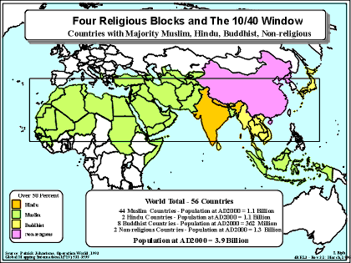

The “10/40 Window” is an area of the world located between 10 degrees latitude north of the equator and 40 degrees latitude north and which covers North Africa, the Middle-East, and most of western, central, eastern, and southeastern Asia.

Within the 10/40 Window resides …

Notes

______________________

- 60% of the world’s population (4.5 billion)

- The (55) least-reached nations of the world

- (86%) of the world's least-reached ethnic groups

- Less than (5%) of the world’s missionaries

- What we expect to result from this conference:

- We will help to (finish) the Great Commission in this generation!

ARGENTINA WILL BE BLESSED!

“That the Lamb who was slain might receive the reward of His sufferings!”
(The heart cry of the Moravians)

Commitment #1: Will you commit to seek God with your whole heart for bigger vision, deeper passion, clearer strategy, and long-term commitment?

Notes

______________________

GREAT COMMISSION EQUIPPING CONFERENCE
(Training Leaders to Impact the World)
I. Introduction

- This is a conference about how you and your church can help finish The Great Commission in this generation – and impact the world around you in the process.

- We desire to help connect you and your church with God’s End-time Harvest in Argentina and around the world.

- A Question: If you had only a few minutes left to live on earth, what would your final words be to your family and friends?

- A Truth: When Jesus had five minutes left on earth, He gave us the (Great Commission) (Matthew 28:16-20; Mark 16:15)

- Go – reach everyone in your world
- Make disciples, not just church members
- Reach every ethnic group
- Baptize believers and teach them to obey

- The Great Commission is repeated at least (five) times in the New Testament – once at the close of each of the four Gospels (Matthew 28:16-20; Mark 16:15-18; Luke 24:46-47; John 20:21) and once in Acts 1:8. It is also referenced in Matthew 24:14.

- In The Great Commission, Christ has given us a (mandate) .

- A mandate is not a suggestion; rather it is a very important command.

- A mandate releases authority and (responsibility) from the one who issues the command.

- A mandate deals with matters of utmost importance.

- Our mandate from Christ is to (make disciples) in every ethnic group on earth.

II. Here’s What You Will Learn (Conference Overview):

Notes

1. How to win more new believers and how to teach them to (obey) Jesus and (fish) for men.

2. How to deeply impact our communities by bringing the Good News of the Kingdom of God to all the people around you.

3. That the world (and Argentina) is made up of many different (ethnic groups) who need Christ.

4. The first five of the ten characteristics of churches which (impact) the world (Great Commission Churches).

5. Important (definitions) of key words used in this training.

6. How to (release) your church for evangelism and missionary church planting in Argentina and around the world.

7. How to develop better (strategy) for winning Argentina, Latin America, and the world to Christ and helping complete The Great Commission in this generation.

III. Important Definitions of Key Words: In order to fully understand the teaching of this conference, you will need to become familiar with the following definitions. Please study them carefully:

- “The Great Commission”: “The work of the church in making disciples in Jerusalem, Judea, Samaria, and the ends of the
earth.”

- “Missions” – “the (cross-cultural) work of the Great Commission.”

- “ (Missionary) ” – “a person who enters another culture in order to make disciples and plant new churches.”

- “People-group” – “a group of people who share common
ethnic, cultural and linguistic traits.” Note: People groups must become the strategic target of missions if we are to finish The Great Commission.

- “ (Unreached) people group” – an ethnic group where

Notes

most of the adherents live their entire lives without ever hearing an understandable presentation of the Gospel.

- “A Great Commission Church” – “a church which trains its members to win lost people, disciple the new believers, and help finish The Great Commission in this generation.”

- “A Great Commission Believer” – “a believer who (obeys) Jesus, (fishes) for men, and trains other believers to do the
same.”

- “A Church Planting Movement” – “a (rapid multiplication) of new believers and churches that sweeps through an area or an ethnic group.”

- “An (Indigenous) Church” – “a native or home-grown
church (as opposed to a foreign or alien one) which is familiar to, comfortable for, and led by the people group being reached.” This often results in many people from that group coming to Christ.

- “Closure” – “the concept that the Great Commission
can be (completed) in a measurable way by establishing an indigenous church planting movement in every ethnic group on earth.”

A STORY OF TWO CHURCHES: An “ordinary” church and a “Great Commission Church.”

Commitment #2: Will you commit to see your church be transformed into a Great Commission Church (an Impact Church)?

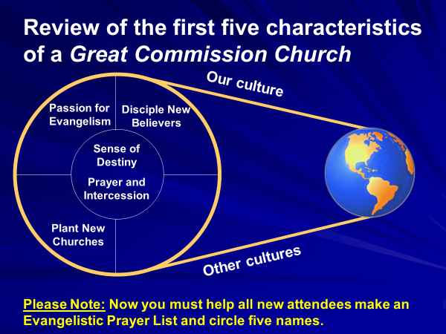

Notes

IV. Ten Characteristics of Great Commission Churches:

Review of the first five characteristics (from Phase 1):

- Great Commission churches have a “sense of
destiny.” (The first characteristic of impact churches)

- Great Commission Churches are committed to
prayer and intercession. (The second characteristic of
impact churches)

3. Great Commission Churches have a passion for evangelism. (The third characteristic of impact churches)

- Great Commission churches disciple new believers. (The fourth characteristic of impact churches)

- Great Commission churches have a commitment to
plant new churches. (The fifth characteristic of impact churches)

NEW TEACHING BEGINS HERE:

Notes

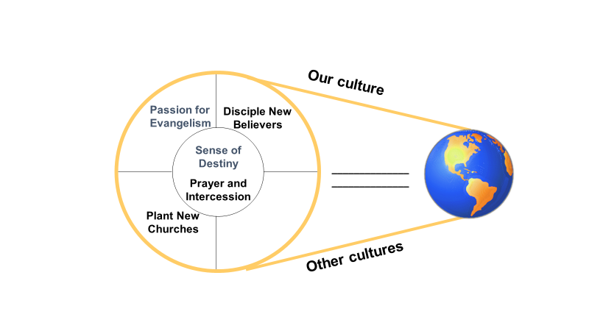

6. Great Commission churches have a passion to (finish) the Great Commission. (The sixth characteristic of impact churches)

THE STATE OF THE WORLD:
- Global Population Trends
Current world population is over (7.6 billion) , and it is growing by (200,000) every day.

11% - True Believers (purple);
22% - Nominal Christians (green)
39% - Reside within reached people groups (blue);
28% - Virtually no exposure to the Gospel – Unreached Peoples (yellow)

This population explosion means that we must get more serious about evangelism and church planting.

Notes

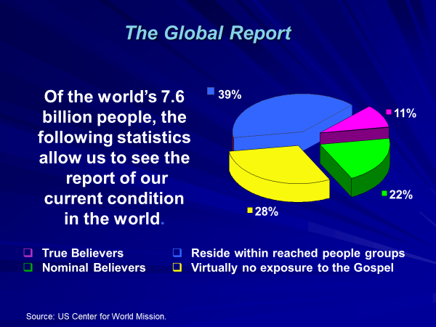

Notes

- The Status of Global Evangelization:

Numbers of People Groups in the World:

Total reached people groups: (9,849)
Total unreached people groups: (6,738)
Total people groups: (16,587)

COUNTRIES WITH THE MOST UNREACHED PEOPLE GROUPS:

(India) -- 2,077 Unreached Peoples
(China) -- 442 Unreached Peoples
(Pakistan) -- 381 Unreached Peoples
(Bangladesh) -- 282 Unreached Peoples
(Nepal) -- 242 Unreached Peoples

THE ARGENTINE REPUBLIC

- Has a population of (44,617,000) and is comprised of (84) different ethnic groups.
- Has (184,000) who have yet to hear the Gospel for the first time. Latin America has (773,000) who have yet to hear the Gospel.
- Has (2) and Latin America has (72) unreached ethnic groups.
- Is (11%) evangelical and 83.3% Catholic. The average annual growth rate of evangelicals in Argentina is 2.1%. In Nepal it is 10.9%, China is 10.8%, Cambodia is 5.9%, Burkina Faso is 4.8%, Kuwait is 4.2%, USA is 0.8%.
- Has a literacy rate of 98%.
- (51) different languages are spoken in Argentina.

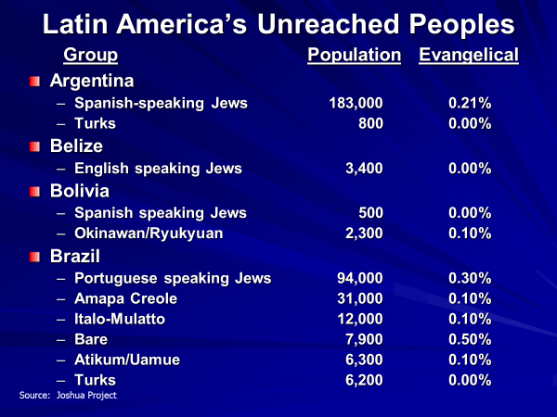

Notes

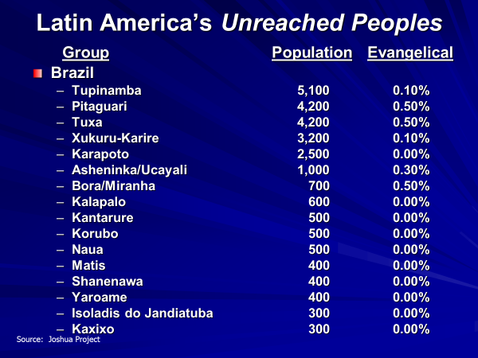

Notes

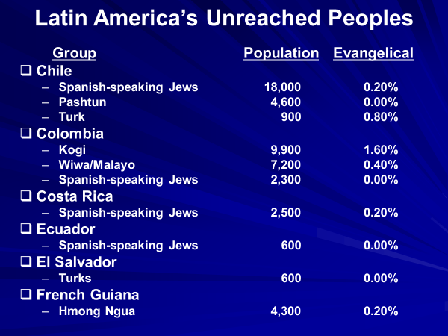

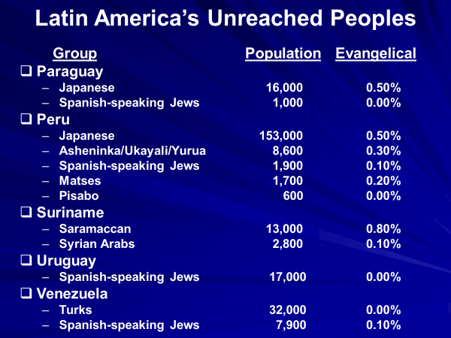

Notes

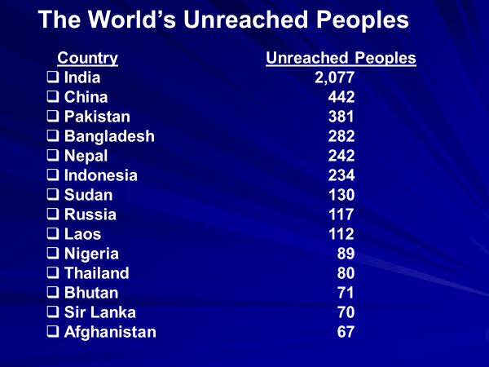

Commitment #3: Will you commit to adopt one or two Unreached Peoples for prayer and church planting?

We must pray to see The Great Commission
finished in Argentina, Latin America, and throughout the entire world!

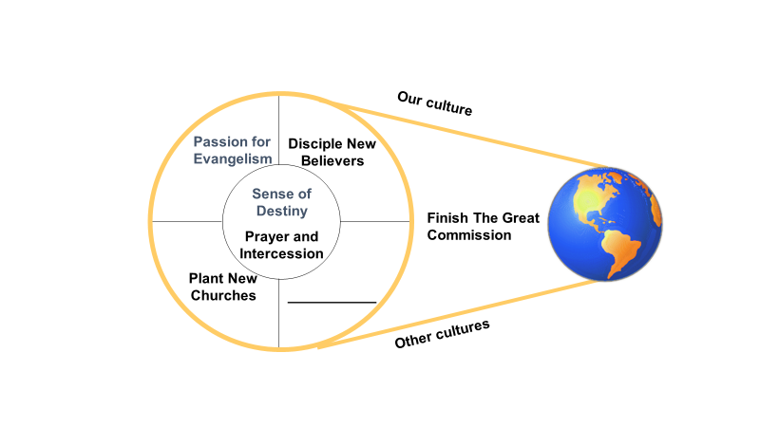

Notes

- Great Commission churches have a clear (strategy) for reaching and discipling those who have not heard. (The seventh characteristic of impact churches)

- The Goal: to help finish The Great Commission by creating a Church Planting Movement in each ethnic group on earth.

- Great Commission churches and organizations do not grow because of circumstances. They grow because they have a wise plan for growth.

- An Example of a Strategy: A Church Planting Movement among Muslims in South Asia:

Their Success:
  - 4,500 Muslims were baptized in 2½ years
  - 314 new Isa Jamaats started in that period
  - Within five years they had baptized 15,000 Muslims and had planted more than 800 Isa Jamaats

How did this happen? This was their strategy:
- They first found 23 Muslim women making baskets for export and talked to them about Jesus

Notes

- Because of their interest, each of the 23 brought their husbands and fathers to a meeting
- Verses dealing with Isa from the Qu’ran were shared which showed Jesus to be more than a prophet (The Qu’ran was used exclusively in the beginning to engage these Muslims)
- These people became angry with their Imam for hiding this truth about Isa
- The group insisted that they meet the following four days to study the Injils (Gospels) in the Bible
- The entire group came to Christ and were organized into six Isa Jamaats

- Great Commission churches take seriously Jesus’s vision and (strategy) for planting churches (Acts 1:8)

- Jerusalem (your city)
- Judea (your state or province)
- Samaria
- Your neighboring states and provinces
- The unclean or despised peoples
- The ends of the earth (unreached) people

- Model of a Great Commission Church:

- (Discipling) and church planting activity …

- Within our own culture
- Within (other) cultures.

- God’s desired result: every culture (people group) on earth included in His Kingdom.

Notes

______________________

- Two approaches to reaching unreached people groups:

- Working through (believers) from unreached people groups who have come to Christ and who have leadership giftings & callings – training them to reach their own people by training trainers

- Sending cross-cultural (missionaries) sent to unreached people groups as “Strategy Coordinators” or coaches

- Our goal: the creation of Church Planting Movements

- Definition: “A (rapid multiplication) of indigenous churches planting churches that sweeps through a people group or population segment.”

- Recent examples of Church Planting Movements:

- A Ministry in East Asia planted 360 churches in 6 months
- A group in Latin America grew from 235 to 4,000 churches with 30,000 baptisms
- 4,000 new churches were planted among the Bhojpuri in India and 3,00,000 new believers added
- In an Asian Muslim country 3,000 Isa Jamaats (Jesus Groups) were formed with 1,50,000 Muslim converts

- Characteristics of Church Planting Movements

- Rapid reproduction of churches (from addition to multiplication)
- Formation of new (House Churches)
- Multiple, unpaid, indigenous lay leadership
- Extraordinary Prayer
- The Bible in the mother language
- (Indigenous) worship
- Rapid discipling and assimilation of new believers
- Missionaries serve as “Strategy Coordinators” or coaches

- What is a “Strategy Coordinator?”

Notes

- A missionary who knows how to plant (many) churches among an Unreached People.
- A missionary who plants (indigenous) churches.
- A missionary who remains in the (background) while training and putting indigenous leaders forward – a coach.
- A missionary who has a (strategy) (plan) and who makes it a high priority for discipling believers and raising up trainers of trainers

- Strategy for training missionaries:

- New believers are trained to reach (family) and
(friends) (using an Evangelistic Prayer List)
- New believers trained to start (new groups) and to
train others to start new groups
- Each new group can become a house church (Don’t start more than six at one time)
- Some will become (large) churches

- The Ying Kai story:

Notes

- His success:

- Began with 30 people in November, 2000
- After 3 months, 27 small groups had been started
- In 2001 the group started 906 small groups in their province
- Took the Gospel to 17 towns in one year
- More than 10,000 people came to Christ in one year
- The next year (2002) they started more than 3,000 house churches and had over 50,000 baptisms

- His strategy:

- Trained each person why they should witness, who to witness to and how to witness
- Taught them how to tell their story and Jesus’ story (Creation to Christ) – let them practice
- Helped each person develop an Evangelistic Prayer List
- Trained them to witness to five people/week
- Trained them to look at every new believer as a trainer of trainers (15-20% will)
- Came back every two weeks to receive their reports and teach them a new lesson
- Used the Three-Thirds Training model

- “The church that does not have a vision to conquer the
world soon dies.” (Pioneer Missiologist Roland Allen)

Commitment #4: Will you commit to develop a strategy to pray for and plant churches among the Unreached People groups you have targeted?

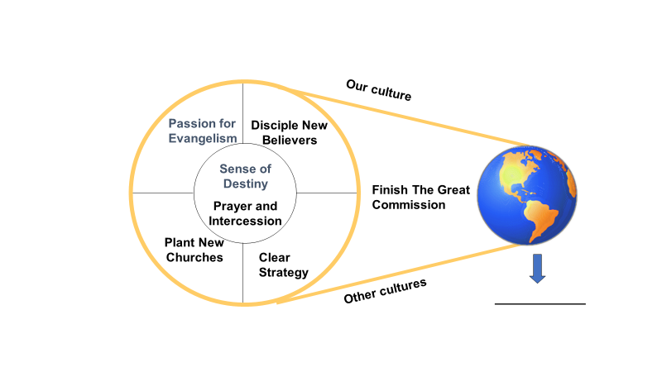

Notes

8. Great Commission churches minister in (supernatural) power. (The eighth characteristic of impact churches)

- The Great Commission was given in the context of the power of the Holy Spirit. (Mark 16:15-18; Acts 1:8 – signs, wonders, healings, and miracles)

- Jesus’ first message: “The Kingdom of Heaven is (present) (at hand) -- Matthew 4:17.

- The Kingdom that was predicted was to be marked by unprecedented (blessing) (peace, joy, justice, deliverance, prosperity, and wholeness)

- This Kingdom would be brought in by the coming Messiah King

- This Kingdom, Jesus said, had now come and was now (within reach) of the people.

Notes

- Jesus’s message of the Kingdom was marked by two things:

  - He (demonstrated) this truth that the Kingdom had indeed come by healing sick people and casting out evil spirits. (Matthew 4:23-25).

  - He sent His disciples out to do what He had done (to preach, to heal the sick, and to cast out evil spirits).

    - Luke 9:1-6 – The sending of the 12
    - Luke 10:1-11 – The sending of the 70

It is estimated that 70% of all church growth in the world today is the result of (signs) and (wonders)

- One study showed that 81% of all Hindus in India who had become Christians was because of signs & wonders

- A Researcher recently returned from Bihar, India: “I interviewed 50 believers. Everyone of them knew Jesus as healer before they knew Him as Savior.”

- This is the most effective way to penetrate the worlds of (Hinduism) , (Islam) , & (Buddhism) .

- “God has been using illness to bring people to
Himself. In the past few months, we’ve had many people show interest in the things of God because they were suffering from a physical ailment. Many unsaved Laotians who couldn’t be helped by doctors or hospitals have turned to our churches for healing prayers. God has shown His power by healing many.” (A National Missionary in Laos)

- Each person who is trained to witness and train other should look for opportunity for God to heal and deliver unsaved people.

- Jesus (anticipated) that His disciples would minister in super-natural power (John 14:12-14). Question: What could you do for God if Jesus used you to heal unsaved people?

- This was Paul’s (strategy) in church planting (Romans15:18-19)

Notes

    - He believed God to work (miracles) among unsaved people. The miracles attracted more people.

    - The miracles helped to affirm Paul in the minds of the people.

    - The miracles were (illustrations) of the character of the Gospel (love, mercy, compassion for the sick)

    - The miracles illustrated the (release) of God’s salvation to the poor, the weak, and the suffering.

- What are the keys to being used in bringing God’s healing and deliverance to people?

- Being (filled) with the Holy Spirit.

  - In the New Testament this infilling of the Spirit often occurred more than once. (See Acts 2:1-4; Acts 4:31)

  - Jesus said the infilling of the Spirit was indispensable for effective ministry (See Acts 1:4).

- Cultivating (intimacy) of relationship with Jesus.

- Power & authority flow from intimacy. Intimacy comes from radical obedience to Jesus.

- Intimacy comes from periods of fasting and prayer

- (Compassion) for hurting people

  - “When Jesus saw a large crowd, He had compassion on them and healed their sick.” (Matthew 14:14)
  - Compassion is like a magnet. It attracts God’ power.

Commitment #5: Will you commit to reach out to unbelievers, asking God to work signs and wonders among them?

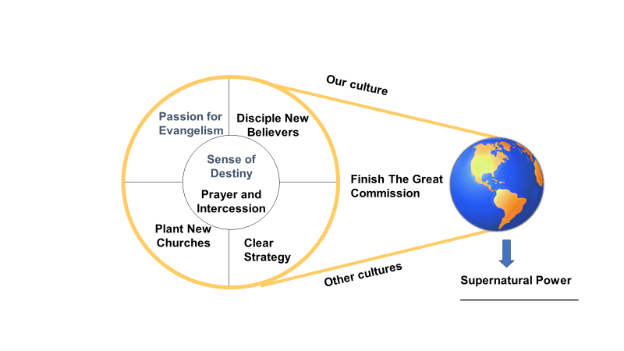

Notes

9. Great Commission churches (send) trained workers into the harvest field. (The ninth characteristic of impact churches)

- The primary purpose of pastors and leaders is to equip the saints for ministry: “So Christ Himself gave the apostles, the prophets, the evangelists, the pastors and teachers, to equip his people for works of service, so that the body of Christ may be built up.” (Ephesians 4:11-12)

- “The size and quality of the work you are able to build for God depends primarily on your ability to effectively (train new leaders).” (James Eby)

- What workers must be equipped to do:

- How to (follow Jesus) (obey Him daily)
- How to (fish for men) (witness to everyone on their list)
- How to (disciple) new believers to disciple others using the Discipling Manual
- How to start (new house churches) and how to teach others to start them

Notes

- “If we continue to focus on growing our church attendance rather than equipping people to be disciple-makers, we will continue to get the stagnant results we currently see." - Rick Wood

- Workers must be equipped to witness (without fear) and to expect (opposition) .

- “I am sending you out like sheep among wolves. Therefore be as shrewd as snakes and as innocent as doves. Be on your guard; you will be handed over to the local councils and be flogged in the synagogues. On my account you will be brought before governors and kings as witnesses to them and to the Gentiles. But when they arrest you, do not worry about what to say or how to say it. At that time you will be given what to say.” (Matthew 10:16-19)
- “Dear friends, do not be surprised at the fiery ordeal that has come on you to test you, as though something strange were happening to you. But rejoice inasmuch as you participate in the sufferings of Christ, so that you may be overjoyed when his glory is revealed.” (1 Peter 4:12-13)

There are about (10,000) Christian martyrs somewhere in the world each year. (Int’l. Society for Human Rights)

- Paul’s experience with persecution (2 Corinthians 11:23-27)

- In prison frequently
- Flogged five times
- Beaten with rods three times
- Stoned
- Shipwrecked three times
- In constant danger
- Often went without sleep

- Things to remember when witnessing in difficult situations:
    - Never (argue) with people about anything. Walk away.
    - Let the person know he is loved
    - God can deliver us; sometimes He chooses not to
    - Be willing to (suffer) for Christ’s sake

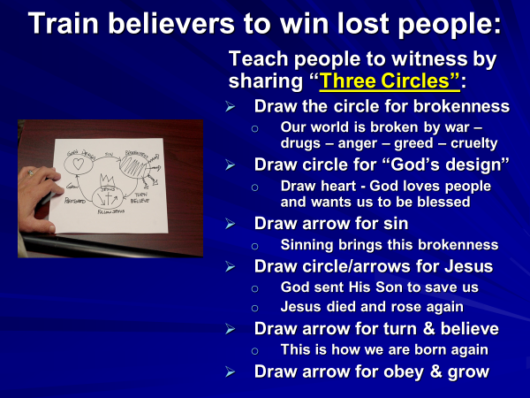

Notes

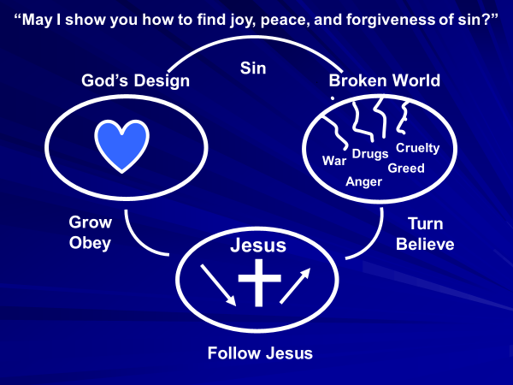

- Things to remember when equipping workers:

Notes

- You have potential workers in your church right now
- Meet with trainees regularly – establish (accountability)
- Spend most of your time with (fruitful) workers
- Training must be frequent, extensive, and practical
- Target (unreached) areas for church planting
- Aim for (fourth) generation believers and churches

Commitment #6: Will you commit to sending trained workers from your church into the harvest?

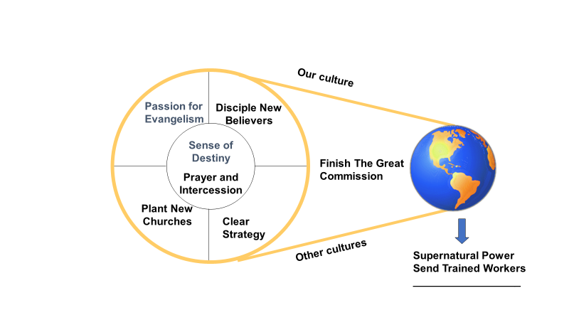

10. Great Commission Churches (give generously) to the cause of World Evangelization. (The tenth characteristic of churches which impact the world.)

Notes

- No believer or church is too poor to give
- Giving brings God’s favor and blessing
- To be dependent on the West for finances is to be seriously (crippled) in our efforts to evangelize Argentina.
- Every church should establish a fund for evangelism & missions:
- Immediate goal: Every Impact Church should set aside at least (10%) of its income to reach those who have not heard.
- Long-term goal: At least (25-40%) of the church’s total annual income given to evangelistic outreach.
God has promised to bless people and churches who give generously.

THE PRINCIPLES OF BIBLICAL GIVING AND GOD’S BLESSING
- Introduction to Biblical Giving
    - This teaching is based on God’s (promises) to Abraham (Genesis 12)):
      - “I will bless you”
      - “I will make you a blessing” (Father of Nations)
    - Biblical giving is a way that you also can be blessed and be a (blessing) to the nations.
    - “If you belong to Christ, then you are Abraham’s seed and heirs according to the promise.” (Galatians 3:29)

- Principle # 1 – Christian giving begins with the (tithe) .
    - In the beginning God taught His people to give by tithing
    - Tithe means “tenth” (10%). It is the spiritual practice of giving to God the first 10% of everything He gives us.
    - Tithing was practiced by Abraham, Isaac, and Jacob 400 years before the Law was given.

Notes

    - Israel was instructed to bring the first-fruits of their crops and their herds – a principle with God (give the first 10%)
    - Israel was instructed to bring the (first-fruits) of their crops and their herds – a principle with God: believers are to give the (first) 10% of our increase)
    - “We also assume responsibility for bringing to the house of the Lord each year the firstfruits of our crops and of every fruit tree. As it is also written in the Law, we will bring he first-born of our sons and of our cattle, of our herds and of our flocks, to the house of our God, to the priests ministering there. Moreover, we will bring to the storerooms of the house of our God, to the priests, the first of our ground meal, of our grain offerings, of the fruit of all our trees and of our new wine and oil. And we will bring a tithe of our crops to the Levites, for it is the Levites who collect the tithes in all the towns where we work.” (Nehemiah 10:35-37)
    - It was a serious offense for Israel to withhold the tithe (Malachi 3:8-9) – because of God’s desire to bless people
    - The practice of tithing was affirmed by (Jesus) . (Matthew 23:23; Luke 11:42)
    - Tithing is a step of (faith) or trust that God will bless us just as He said (Malachi 3:10)
    - This is the way God has always funded ministry in His Kingdom. Challenge people to give to fulfill the church’s vision.
    - Tithing is the one area where God told Israel to (test) (Malachi 3:10)

- Principle # 2 – Our giving should be (regular) giving.
    - We should give the first 10% of our increase as it comes, when it comes in
      - When crops are harvested
      - When baby goats, cows and pigs are born
      - Whenever God blesses us with anything
    - When you get behind in your tithing, it’s hard to catch up
    - “Honor the Lord with your possessions, and with the first-fruits of all your increase; so your barns will be filled with plenty, and your vats will overflow with new wine.” (Proverbs 3:9)

Notes

    - “Now about the collection for God’s people: Do what I told the Galatian churches to do. On the first day of every week, each one of you should set aside a sum of money in keeping with his income.” (1 Corinthians 16:1-2)

- Principle # 3 – Our giving should be done (secretly) (without show) and (cheerfully) .
    - We must never make a show of our giving
“Be careful not to do your acts of righteousness before men, to be seen by them. If you do, you will have no reward in heaven … But when you give to the needy, do not let your left hand know what your right hand is doing, so that your giving may be in secret. Then your Father, who sees what is done in secret, will reward you. (Matthew 6:1-4)
    - Pastors must never put pressure on people to give or (condemn) them when they don’t give. Rather they should just teach them what God says about giving and challenge them to put God to the test.
“Each man should give what he has decided in his heart to give, not reluctantly or under compulsion, for God loves a cheerful giver.” (1 Corinthians 9:7)

- Principle # 4 – God rewards us according to our (generosity) in giving.
    - We (reap) according to what we (sow) .
“Remember this: Whoever sows sparingly will also reap sparingly, and whoever sows generously will also reap generously.” (2 Corinthians 9:6)
“Give and it will be given to you. A good measure, pressed down, shaken together and running over, will be poured into your lap. For with the measure you use, it will be measured to you.” (Luke 6:38)
    - When we fail to give, we are like a farmer who eats his seed and has no seed to plant next year. Please don’t eat your seed.

Notes

    - Our giving should extend beyond the tithe; tithing is where Christian giving (begins) .

- Principle # 5 – Our giving is to be done in (faith) .
    - Tithing is an act of faith. We give the first of God’s blessings back to Him.
    - Our obedience to God in giving allows us to claim all of (God’s promises) to us about giving.
“And God is able to make all grace abound to you, so that in all things at all times, having all that you need, you will abound in every good work. As it is written, ‘He has scattered abroad his gifts to the poor; his righteousness endures forever.’ Now He who supplies seed to the sower and bread for food will also supply and increase your store of seed, and will enlarge the harvest of your righteousness. You will be made rich in every way so that you can be generous on every occasion…. ” (2 Corinthians 9:8-11)
    - The way we fight the enemy is by standing on God’s faithful promises.

Commitment #7: Will you commit to being a tither personally and training your people to be faithful tithers?

Notes

SEMINAR SUMMARY

- Four Great Historical “Waves” of Missionary Activity:
  - The “First Wave” – the first-century (Apostles)
  - The “Second Wave” – the (Protestant) Missionary Movement (William Carey, Hudson Taylor, David Livingstone, etc.)
  - The “Third Wave” – the Pentecostal/Charismatic (Renewal) (Youth With A Mission, Operation Mobilization, Campus Crusade for Christ, Pentecostal/Charismatic denominations, Independent church movements)
- The “Final Wave” – the missions movement of the (Majority World) - this is the wave that will see The Great Commission finished in this generation!

The leadership of missions in the world is changing hands – it is moving from white hands to brown, black, and yellow hands.

What is the world’s most recognizable logo or trademark?

Notes

Coca-Cola Facts:

- Logo recognized by 94% of the world’s population

- 800,000,000 sales per day in over 200 countries

- Coca-Cola trucks travel over 1,000,000 miles/day

Two Questions:

Notes

1. If Coca-Cola has reached 94% of the world’s population in 120 years, why haven’t Christians been able to do it in 2,000 years?
2. Do we need to repent of our disobedience to Christ, our lack of vision and commitment, and our lack of strategic focus?

- Final Challenges:
  - How are you going to live the remainder of your life? Why not invest it in something that will make a genuine difference in the world?
  - Will you adopt one of Argentina’s Unreached Peoples for church planting?
  - “If God is your partner, make your plans big.” (D. L. Moody)
  - Get a vision that is worth dying for!

Your assignment for the coming five years:

  - Be committed to see your church become a (Great Commission) church.
  - Get a vision that is worth dying for. Get pregnant with a vision from God (spend significant time in prayer & fasting)
  - Teach each believer to have an Evangelistic Prayer List and to commit to reach his family and friends through prayer and witnessing.
  - Teach believers to (disciple) each new believer they win by teaching the eight lessons in the Discipling Manual.
  - Commit to have one week of (fasting and prayer) each three months
  - Commit to plant many (new churches) – impact your area for Christ!
  - Believe God to work miracles, especially among (unsaved people)
  - (Adopt) an Unreached/Unengaged People and commit to reach them
  - Regularly teach your people to (give generously) to help reach Argentina for Christ (tithing and special giving) and watch God bless

- Two Closing Thoughts:
  - “In view of the constraining memories of the Cross of Christ and the love wherewith He hath loved us, let us rise and resolve, at whatever the cost of self-denial, that, live or die, we shall live or die for the evangelization of the world in our day.”
(Missionary Statesman John R. Mott)

Notes

  - “He is no fool who gives what he cannot keep to gain what he cannot lose.” (Missionary Martyr Jim Elliott)

CHURCH PLANTING/UPG COMMITMENT FORM

By God’s grace, I commit myself today to help finish The Great Commission in Argentina by taking the responsibility to see a Church Planting Movement take place among the following unreached/unengaged people group in Argentina during the next five years: _______________________ ________________________

Date: ________________________________
Name (print) ________________________________________________________________
Postal Address ________________________________________________________________
_____________________________________________________________________________

Mobile telephone number: _________________________

E-mail address: _____________________

Signature: __________________________

If you were not at the Phase One Conference: I commit myself today to help finish The Great Commission in Argentina by reaching at least ______ new believers and seeing at least _____ new house churches among my people in the next five years.

I will also take the responsibility for training believers in my church to help carry out this task.

CHURCH PLANTING/UPG COMMITMENT FORM

By God’s grace, I commit myself today to help finish The Great Commission in Argentina by taking the responsibility to see a Church Planting Movement take place among the following unreached/unengaged people group in Argentina during the next five years: _______________________ ____________________

Date: ________________________________
Name (print) ________________________________________________________________
Postal Address ________________________________________________________________
_____________________________________________________________________________

Mobile telephone number: _________________________

E-mail address: _____________________

Signature: __________________________

If you were not at the Phase One Conference: I commit myself today to help finish The Great Commission in Argentina by reaching at least ______ new believers and seeing at least _____ new house churches among my people in the next five years.

I will also take the responsibility for training believers in my church to help carry out this task.

Review and Progress Update
(Fill out form and turn in – for those who attended Phase One)

Since our last meeting (the Phase One Great Commission Conference) …
- Did you get alone with God for an extended time of prayer & fasting (finding a Sense of Destiny)? Yes ____; No ____. If you did, please describe what happened: ________________________________________
_______________________________________________________________
_______________________________________________________________
_______________________________________________________________
_______________________________________________________________

- How many people did you teach to reach their family and friends through prayer and witnessing (Evangelistic Prayer List)? ____________

- How many people have come to Christ in your ministry since our last meeting? _______

- How many people have taken baptism since our last meeting? _______

- How many trainers have you trained who are now regularly training other trainers? _________

- How many new groups (house churches) have been started in your ministry since our last meeting? __________

Did you have a Prayer Revival (a week of fasting and prayer) in your church each three months since our last meeting? __________

ANSWER PAGE

Page 3

God’s Objective
people group
God’s Vision

Page 4

God’s Strategy
ethnic group
God’s Method
Christ’s Mandate
finish
vision
passion
strategy
commitment

Page 5
unreached
2
72
7,000
42,000

Page 6
55
86%
5%
finish

Page 7

Great Commission
five
mandate
responsibility
make disciples

Page 8
obey
fish
ethnic groups
Impact
definitions
release
strategy
cross-cultural
Missionary

Page 9

unreached

obeys

fishes

rapid multiplication

indigenous

completed

Page 11
finish
7.6 billion
200,000

Page 13
9,849
6,738
16,587
India
China
Pakistan
Bangladesh
Nepal
44,617,000
84
184,000
773,000
2

72

11%

51

Page 17
strategy

Page 18
strategy
unreached
discipling
other

Page 19
believers
missionaries
rapid multiplication
house churches
Indigenous

Strategy Coordinators

Page 20
many
indigenous
background
strategy
family
friends
new groups
large

Page 22
supernatural
present
blessing
within reach

Page 23
demonstrated
signs
wonders
Hinduism
Islam
Buddhism
anticipated

Page 24
strategy
miracles
illustrations
release
filled
intimacy
compassion

Page 25
send
train new leaders
follow Jesus
fish for men
disciple
new house churches

Page 26
without fear
opposition
10,000
argue
suffer

Page 28
accountability
fruitful
unreached
fourth

Page 29

give generously
crippled
10%
25-40%
promises
blessing
tithe

Page 30
first-fruits
first

Jesus
faith
test
regular

Page 31
secretly
cheerfully
condemn

generosity
reap
sow

Page 32
begins
faith
God’s promises

Page 33

Apostles
Protestant
Renewal
Majority World

Page 36

Great Commission

disciple
fasting and prayer
new churches
unsaved people
Adopt
give generously

